**Spring Core and Maven**

**Exercise 1: Configuring a Basic Spring Application**

**Pom.xml**

<project xmlns="http://maven.apache.org/POM/4.0.0" xmlns:xsi="http://www.w3.org/2001/XMLSchema-instance" xsi:schemaLocation="http://maven.apache.org/POM/4.0.0 https://maven.apache.org/xsd/maven-4.0.0.xsd">

<modelVersion>4.0.0</modelVersion>

<groupId>com.library</groupId>

<artifactId>LibraryManagement</artifactId>

<version>0.0.1-SNAPSHOT</version>

<dependencies>

<!-- Spring Context -->

<dependency>

<groupId>org.springframework</groupId>

<artifactId>spring-context</artifactId>

<version>5.3.30</version> <!-- You can use latest if available -->

</dependency>

</dependencies>

</project>

**applicationContext.xml**

<?xml version="1.0" encoding="UTF-8"?>

<beans xmlns="http://www.springframework.org/schema/beans"

xmlns:xsi="http://www.w3.org/2001/XMLSchema-instance"

xsi:schemaLocation="

http://www.springframework.org/schema/beans

https://www.springframework.org/schema/beans/spring-beans.xsd">

<bean id="bookRepository" class="com.library.repository.BookRepository"/>

<bean id="bookService" class="com.library.service.BookService">

<property name="bookRepository" ref="bookRepository"/>

</bean>

</beans>

**BookRepository.java**

package com.library.repository;

public class BookRepository {

public void saveBook(String bookName) {

System.out.println("Book '" + bookName + "' saved to the repository.");

}

}

**BookService.java**

package com.library.service;

import com.library.repository.BookRepository;

public class BookService {

private BookRepository bookRepository;

public void setBookRepository(BookRepository bookRepository) {

this.bookRepository = bookRepository;

}

public void addBook(String bookName) {

System.out.println("Adding book: " + bookName);

bookRepository.saveBook(bookName);

}

}

**MainApp.java**

package com.library;

import org.springframework.context.ApplicationContext;

import org.springframework.context.support.ClassPathXmlApplicationContext;

import com.library.service.BookService;

public class MainApp {

public static void main(String[] args) {

ApplicationContext context = new ClassPathXmlApplicationContext("applicationContext.xml");

BookService bookService = (BookService) context.getBean("bookService");

bookService.addBook("Spring in Action");

}

}

Output:

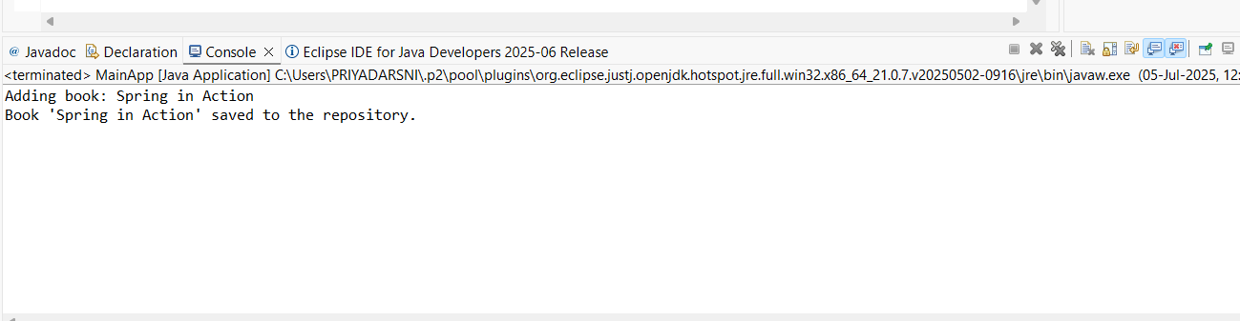

**Exercise 2: Implementing Dependency Injection**

**applicationContext.xml**

<?xml version="1.0" encoding="UTF-8"?>

<beans xmlns="http://www.springframework.org/schema/beans"

xmlns:xsi="http://www.w3.org/2001/XMLSchema-instance"

xsi:schemaLocation="

http://www.springframework.org/schema/beans

https://www.springframework.org/schema/beans/spring-beans.xsd">

<!-- BookRepository bean -->

<bean id="bookRepository" class="com.library.repository.BookRepository" />

<!-- BookService bean with DI -->

<bean id="bookService" class="com.library.service.BookService">

<!-- Dependency Injection: setter method will be called -->

<property name="bookRepository" ref="bookRepository" />

</bean>

</beans>

**MainApp.java**

package com.library;

import org.springframework.context.ApplicationContext;

import org.springframework.context.support.ClassPathXmlApplicationContext;

import com.library.service.BookService;

public class MainApp {

public static void main(String[] args) {

ApplicationContext context = new ClassPathXmlApplicationContext("applicationContext.xml");

BookService bookService = (BookService) context.getBean("bookService"); bookService.addBook("The Spring Framework Handbook");

}

}

Output:

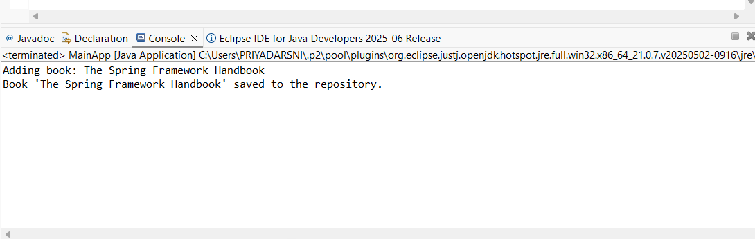

**Exercise 3: Implementing Logging with Spring AOP**

**LoggingAspect.java**

package com.library.aspect;

import org.aspectj.lang.ProceedingJoinPoint;

public class LoggingAspect {

public Object logExecutionTime(ProceedingJoinPoint joinPoint) throws Throwable {

long start = System.currentTimeMillis();

Object returnValue = joinPoint.proceed(); // method execution

long timeTaken = System.currentTimeMillis() - start;

System.out.println("[LOG] Method " + joinPoint.getSignature() + " executed in " + timeTaken + " ms");

return returnValue;

}

}

**applicationContext.xml**

<?xml version="1.0" encoding="UTF-8"?>

<beans xmlns="http://www.springframework.org/schema/beans"

xmlns:xsi="http://www.w3.org/2001/XMLSchema-instance"

xmlns:aop="http://www.springframework.org/schema/aop"

xsi:schemaLocation="

http://www.springframework.org/schema/beans

https://www.springframework.org/schema/beans/spring-beans.xsd

http://www.springframework.org/schema/aop

https://www.springframework.org/schema/aop/spring-aop.xsd">

<!-- BookRepository Bean -->

<bean id="bookRepository" class="com.library.repository.BookRepository" />

<!-- BookService Bean -->

<bean id="bookService" class="com.library.service.BookService">

<property name="bookRepository" ref="bookRepository"/>

</bean>

<!-- Aspect Bean -->

<bean id="loggingAspect" class="com.library.aspect.LoggingAspect" />

<!-- AOP Config -->

<aop:config>

<aop:aspect ref="loggingAspect">

<aop:around method="logExecutionTime"

pointcut="execution(* com.library.service.*.*(..))"/>

</aop:aspect>

</aop:config>

</beans>

**MainApp.java**

package com.library;

import org.springframework.context.ApplicationContext;

import org.springframework.context.support.ClassPathXmlApplicationContext;

import com.library.service.BookService;

public class MainApp {

public static void main(String[] args) {

ApplicationContext context = new ClassPathXmlApplicationContext("applicationContext.xml");

BookService bookService = (BookService) context.getBean("bookService");

// Run method to test logging

bookService.addBook("Clean Code");

}

}

Output:

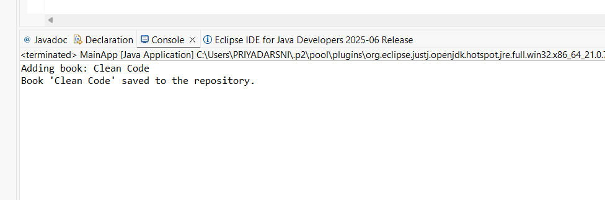

**Exercise 4: Creating and Configuring a Maven Project**

**pom.xml**

<project xmlns="http://maven.apache.org/POM/4.0.0"

xmlns:xsi="http://www.w3.org/2001/XMLSchema-instance"

xsi:schemaLocation="http://maven.apache.org/POM/4.0.0

http://maven.apache.org/xsd/maven-4.0.0.xsd">

<modelVersion>4.0.0</modelVersion>

<groupId>com.library</groupId>

<artifactId>LibraryManagement</artifactId>

<version>1.0-SNAPSHOT</version>

<properties>

<maven.compiler.source>1.8</maven.compiler.source>

<maven.compiler.target>1.8</maven.compiler.target>

</properties>

<dependencies>

<!-- Spring Context -->

<dependency>

<groupId>org.springframework</groupId>

<artifactId>spring-context</artifactId>

<version>5.3.30</version>

</dependency>

<!-- Spring AOP -->

<dependency>

<groupId>org.springframework</groupId>

<artifactId>spring-aop</artifactId>

<version>5.3.30</version>

</dependency>

<!-- Spring Web MVC -->

<dependency>

<groupId>org.springframework</groupId>

<artifactId>spring-webmvc</artifactId>

<version>5.3.30</version>

</dependency>

<!-- AspectJ (for AOP) -->

<dependency>

<groupId>org.aspectj</groupId>

<artifactId>aspectjweaver</artifactId>

<version>1.9.21</version>

</dependency>

</dependencies>

<!-- Maven Compiler Plugin for Java 1.8 -->

<build>

<plugins>

<plugin>

<artifactId>maven-compiler-plugin</artifactId>

<version>3.8.1</version>

<configuration>

<source>1.8</source>

<target>1.8</target>

</configuration>

</plugin>

</plugins>

</build>

</project>

Output:

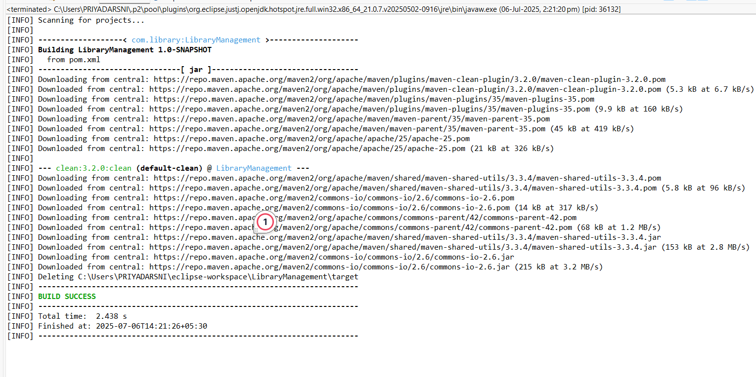

**Exercise 5: Configuring the Spring IoC Container**

**applicationContext.xml**

<?xml version="1.0" encoding="UTF-8"?>

<beans xmlns="http://www.springframework.org/schema/beans"

xmlns:xsi="http://www.w3.org/2001/XMLSchema-instance"

xsi:schemaLocation="

http://www.springframework.org/schema/beans

https://www.springframework.org/schema/beans/spring-beans.xsd">

<!-- Define BookRepository bean -->

<bean id="bookRepository" class="com.library.repository.BookRepository" />

<!-- Define BookService bean and inject BookRepository -->

<bean id="bookService" class="com.library.service.BookService">

<property name="bookRepository" ref="bookRepository" />

</bean>

</beans>

**BookService.java**

package com.library.service;

import com.library.repository.BookRepository;

public class BookService {

private BookRepository bookRepository;

// Setter for dependency injection

public void setBookRepository(BookRepository bookRepository) {

this.bookRepository = bookRepository;

}

public void addBook(String bookName) {

System.out.println("Adding book: " + bookName);

bookRepository.saveBook(bookName);

}

}

**BookRepository.java**

package com.library.repository;

public class BookRepository {

public void saveBook(String bookName) {

System.out.println("Book '" + bookName + "' saved successfully.");

}

}

**MainApp.java**

package com.library;

import org.springframework.context.ApplicationContext;

import org.springframework.context.support.ClassPathXmlApplicationContext;

import com.library.service.BookService;

public class MainApp {

public static void main(String[] args) {

// Load Spring configuration

ApplicationContext context = new ClassPathXmlApplicationContext("applicationContext.xml");

// Get the BookService bean

BookService bookService = (BookService) context.getBean("bookService");

// Use the service

bookService.addBook("Design Patterns in Java");

}

}

Output:

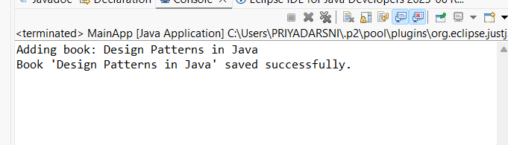

**Exercise 6: Configuring Beans with Annotations**

**applicationContext.xml**

<?xml version="1.0" encoding="UTF-8"?>

<beans xmlns="http://www.springframework.org/schema/beans"

xmlns:context="http://www.springframework.org/schema/context"

xmlns:xsi="http://www.w3.org/2001/XMLSchema-instance"

xsi:schemaLocation="

http://www.springframework.org/schema/beans

https://www.springframework.org/schema/beans/spring-beans.xsd

http://www.springframework.org/schema/context

https://www.springframework.org/schema/context/spring-context.xsd">

<!-- Enable annotation-based bean scanning -->

<context:component-scan base-package="com.library" />

</beans>

BookRepository.java

package com.library.repository;

import org.springframework.stereotype.Repository;

@Repository

public class BookRepository {

public void saveBook(String bookName) {

System.out.println("Book '" + bookName + "' saved successfully.");

}

}

**BookService.java**

package com.library.service;

import org.springframework.beans.factory.annotation.Autowired;

import org.springframework.stereotype.Service;

import com.library.repository.BookRepository;

@Service

public class BookService {

private BookRepository bookRepository;

@Autowired // Automatically inject BookRepository

public void setBookRepository(BookRepository bookRepository) {

this.bookRepository = bookRepository;

}

public void addBook(String bookName) {

System.out.println("Adding book: " + bookName);

bookRepository.saveBook(bookName);

}

}

**MainApp.java**

package com.library;

import org.springframework.context.ApplicationContext;

import org.springframework.context.support.ClassPathXmlApplicationContext;

import com.library.service.BookService;

public class MainApp {

public static void main(String[] args) {

ApplicationContext context = new ClassPathXmlApplicationContext("applicationContext.xml");

BookService bookService = context.getBean(BookService.class);

bookService.addBook("Spring in Action (Annotation Edition)");

}

}

Output:

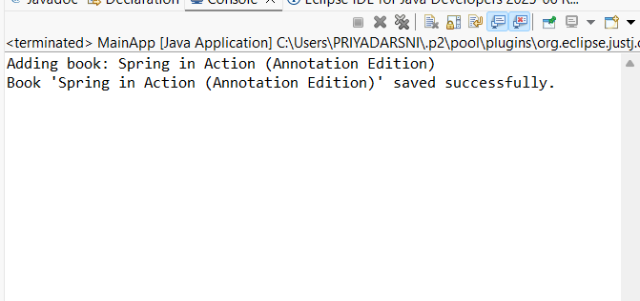

**Exercise 7: Implementing Constructor and Setter Injection**